Reminiscences 1

The development of PET scanning of drug and neurotransmitter receptors in brain
Updated March 23, 2020

(Please note that the previous version of this story on this website became corrupted by unknown means, and some of the original material used to prepare it has been apparently lost or misplaced. My apologies for not appreciating the extent of this problem sooner.)
This is my own story and experience and not an academic review or comprehensive history of the topic. There are many other stories from those who contributed greatly to the area. I acknowledge all of them and I am grateful for their work and support.
The application of PET scanning to the study of receptors in the living human brain was one of the most exciting and rewarding periods of my career. It started sometime in 1978. I was an Associate Professor at Johns Hopkins in the Dept of Pharmacology, and I was part of the Neuropharmacology group lead by the outstanding and pioneering scientist, Sol Snyder. Sol had been identifying drug and neurotransmitter receptors by binding techniques, and I had been focusing on localizing the receptors anatomically with the light microscope. The idea was that if we know where the receptors are localized in the brain, then we can get insights as to how the drugs for those receptors produced their effects. The main approach used to find out where the receptors were in the brain was autoradiography. We and others learned how to inject radiolabeled drugs so that they would bind selectively to receptors, and then by finding the radioactivity we then would know where the receptors were.
One day, and I don’t remember exactly when it was, sometime in 1978 I think, Sol received some visitors who told him about PET scanning and how it might be applied to imaging receptors (I wasn’t there). The basic approach would be the one I was working with, labeling receptors in vivo after intravenous injection of radiolabeled drug or ligand. Sol had his concerns about PET scanning of receptors, and he was negative about my doing it, but I thought that it would build nicely on my expertise in identifying the location of receptors by autoradiography and the light microscope. Therefore, I enthusiastically got involved, and I got to know some of the key people in the PET world.
I went to Brookhaven on May 5, 1978, and observed a PET imaging procedure using a glucose derivative; the experiment was run by Drs Marty Reivich, Al Wolf and Joanna Fowler. It was fascinating to see how a radiolabeled derivative of glucose could be prepared and handled very quickly – quickly was necessary since the positron-emitting isotope had a short half-life. PET used external detectors placed around the head that measured the emissions, and subsequent processing of the data allowed the construction of an image of the distribution of radioactivity in the head without ever invading the head at all. Well, the idea became a big topic of discussion, and Henry Wagner at Hopkins also expressed his interest. He was a radiologist and knew imaging inside and out. We decided to try for a grant. The Brookhaven group asked me to work with them, but Henry Wagner appealed to my loyalty, and I agreed to work only with the Hopkins team.
A first step for our Hopkins group to get into the PET scanning business was to obtain a cyclotron. The cyclotron was needed to synthesize the positron-emitting atoms that they could then be incorporated into drugs for studies of the brain. Wagner’s plan was to write an NIH grant for a state of the art cyclotron. Wagner’s leadership role was essential here because as head of Nuclear Medicine he was able to provide an institutional commitment of funds, space for equipment, and hirings for the project. Without these, nothing would happen.
The grant was titled the “Study of Neuroreceptor Binding in Man” and Wagner was the PI. I was designated the Leader of Project 1, the “Tomographic Localization of Dopamine Receptors in the Brains of Primates and Man”. The goals were to validate the approach for labeling receptors in vivo with non-human primates, and then to proceed to studies with humans and PET scanning. The proposal states that “the identification of conditions which allow selective receptor binding of radiolabeled drugs in vivo after intravenous administration….” has been achieved and three papers from my lab were cited (Atweh and Kuhar, 1977, Brain Res 124;53-68; Kuhar and Yamamura, 1975, Nature 253:560-561; Kuhar et al , 1978, Life Sci, 22:203-210.). The grant (NS 15080) was reviewed at a June 10th study section, received a 188 score and at some point a site visit to Hopkins was planned. The planned start date of the grant was 7/1/79 if funded. In a letter dated April 10, 1979 to Henry Wagner, I outlined some priorities that I thought I would be responsible for, and hoped for a “perfect” site visit. His reply on April 12 was in complete agreement.
My role in the project was limited but fundamental. It had to do with labeling receptors in the brain after intravenous administration of specific radiolabeled compounds. I was the only investigator that had the expertise that focused on the goal of the grant – “receptor binding in man.” No one else on the grant had that experience. Basic issues to be addressed were how to do it, what was required, and how do you know it when you have done it. If preferential labeling of receptors could be done with the ligands prepared with the cyclotron and the chemists, and if the PET machine could measure the level of radioactivity, then receptor imaging should be possible. As I mention above, part of my job was sharing my knowledge of this topic with the group so that it became group knowledge. Also, adequate labeling of receptors required higher specific activity radioligands. This was because receptors are relatively low in numbers, and if there is to be an adequate signal to measure, the average radioactivity per molecule had to be relatively high. At one group meeting, Wagner asked me if I could guarantee that PET imaging of receptors would work. I replied that if the chemists could produce ligands of at least 100 Cu per mmole (which in the world of positron chemistry is easy), then we would be able to preferentially label receptors. That I could guarantee from my earlier experience with animals. Whether the PET instrument could detect it, I wasn’t sure, but it did seem likely when we looked at the specifications of the machines. Moreover, a French group did publish a paper in the 70s on the PET scanning of cholinergic receptors in vivo in the heart; but we just weren’t sure how it would work out in the brain.
On 8/1/79 the cyclotron grant was funded and the cyclotron was purchased! For my project, we did show that after intravenous injection, a radiolabeled opiate drug preferentially bound to opiate receptors in monkeys (Wamsley et al., Neurosci, 7:595-613, 1982). This was not done by PET imaging but by dissecting the brain after administering the radioactive drug and measuring the radioactivity in brain regions by scintillation counting, and further showing that the distribution of radioactivity after in vivo injection was parallel to that of the distribution of receptors previously demonstrated by accepted procedures. In other words, we could selectively label receptors in the brains of monkeys. We were rapidly approaching the time when PET studies in humans could begin.
The five year competing renewal grant application was submitted to the NIH and we were sited visited on Sept 19, 1983. Again Wagner was the PI, I was co-director of the Biology core with James Frost, Jon Links was head of the Physics core, Burns and Dannals and others were in the Chemistry core, Dean Wong was part of a couple of the cores, and there were clinical cores as well. In the end we were approved for 3 more years of funding.
In 1983, we published the first report of dopamine receptor imaging in the living human brain in Science (vol 221: p 1264). Henry Wagner was the human subject! His is the scan that was published (below). The image shown is from a framed one hanging on my office wall. It has the signatures of the individuals that were key in our group in the beginning.
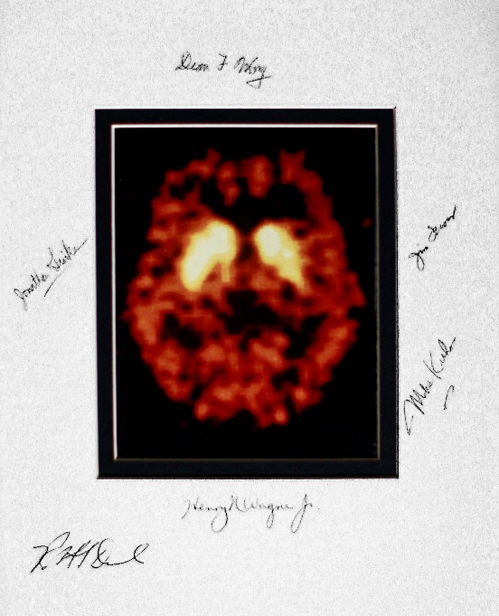
A handwritten note by me in my notebook is as follows: “Yesterday (5/25/83) the first PET scan of receptors in human brain rolled off the NeuroEcat. Wagner on the table, Dean Wong injecting, Jon Links at controls and everyone around! That is now done!” Well, I wasn’t exactly correct. It wasn’t done, it had just begun. On 6/17/83 there was a PET meeting in DC. I gave a good lecture and Wagner was excited, and expressed his desire to be first author on the paper. There was a lot of publicity about the PET work in 1983 and later. There were two very nice articles in the Baltimore Sun (The evening Sun, July 27, 1984; and Evening Sun, Sept 20, 1983) showing Henry Wagner and me standing before the PET scanner and a monitor with a PET image on it (see below).
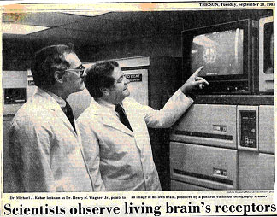
This was like a fairy tale come true. We were now able to look at the sites of action of drugs (i.e., the receptors) in a living human brain by a noninvasive (except for the injection of tracer) procedure. This helped open up the study of receptors in living humans, the study of how therapeutic drugs occupied receptors in the brain, and how receptors were affected by neuropsychiatric disease. This approach has become a standard and enduring one.
It is a nice story of teamwork, synergy and emergence. We all came to the table with our experience and with what we knew and trusted. We pooled it and it worked. I look back and think of key people, of Henry Wagner (Head of the PET Center), Dean Wong (In Vivo Studies), Bob Dannals (Radiochemistry), Jim Frost, Jon Links, Ursulla Scheffel, Don Burns and others. Without them, the Hopkins group would not have been successful. Many of these people continued to make outstanding contributions to the PET literature in succeeding years. There were many individual acts of creativity that worked together, helped us reach our goal, and forge a new field.
It was an amazing time. One of my proudest achievements is that I was able to have acquired an expertise that would be a foundation for PET scanning of receptors, that is, the labeling receptors in vivo with radioligands. Henry Wagner brought us all together and persisted even though the outcome was uncertain. Many human emotions boiled through us all over those years, but we all wonderfully persisted, and in the end, we were successful. In the next several years, the Hopkins PET Center became one of the most productive and prolific centers of its type anywhere at that time.
I recently (in Sept of 2011) found a letter in my files from Henry Wagner dated June 29, 1994. It was a reply to my letter to Henry (dated May 24, 1994) where I said “Looking back over the years, working with you has been great. You are one of Hopkins’ best and it has been a privilege.” Henry’s gracious reply to me said “Your help to me has been far greater than the reverse. I hope we can continue to work together for many years.” It is wonderful to be appreciated.
In March of 2020, I did a PubMed search of PET imaging and receptors. Several thousands of papers and excellent reviews were found. Many creative and insightful studies were included. All of this amazing work and effort is acknowledged.
From another perspective, we succeeded in our early work by standing “on the shoulders” and previous work of many other outstanding investigators. We are grateful for them.

